Version BP – 21.10.8

BB 6648:

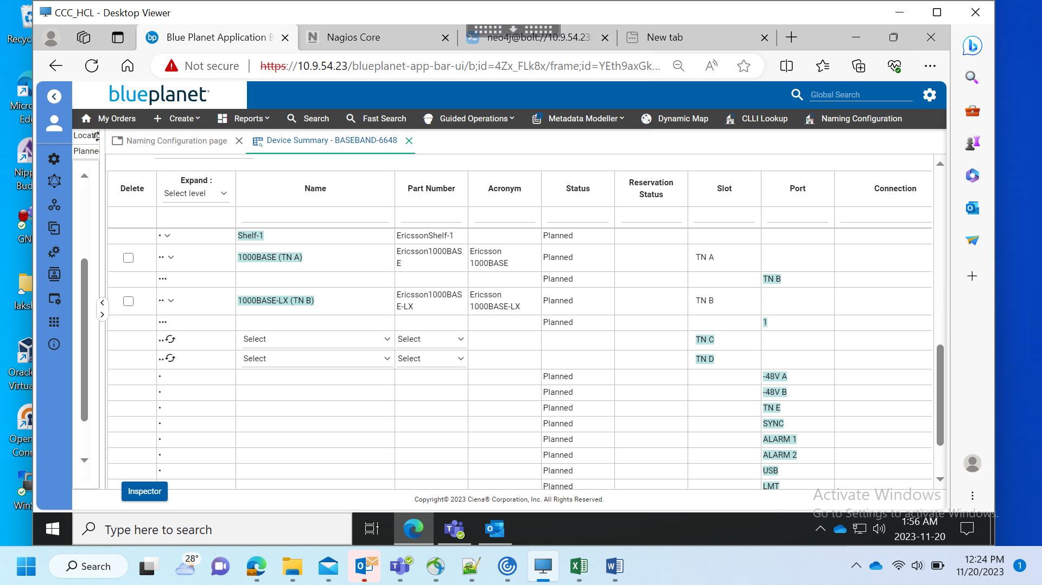

BB 6651:

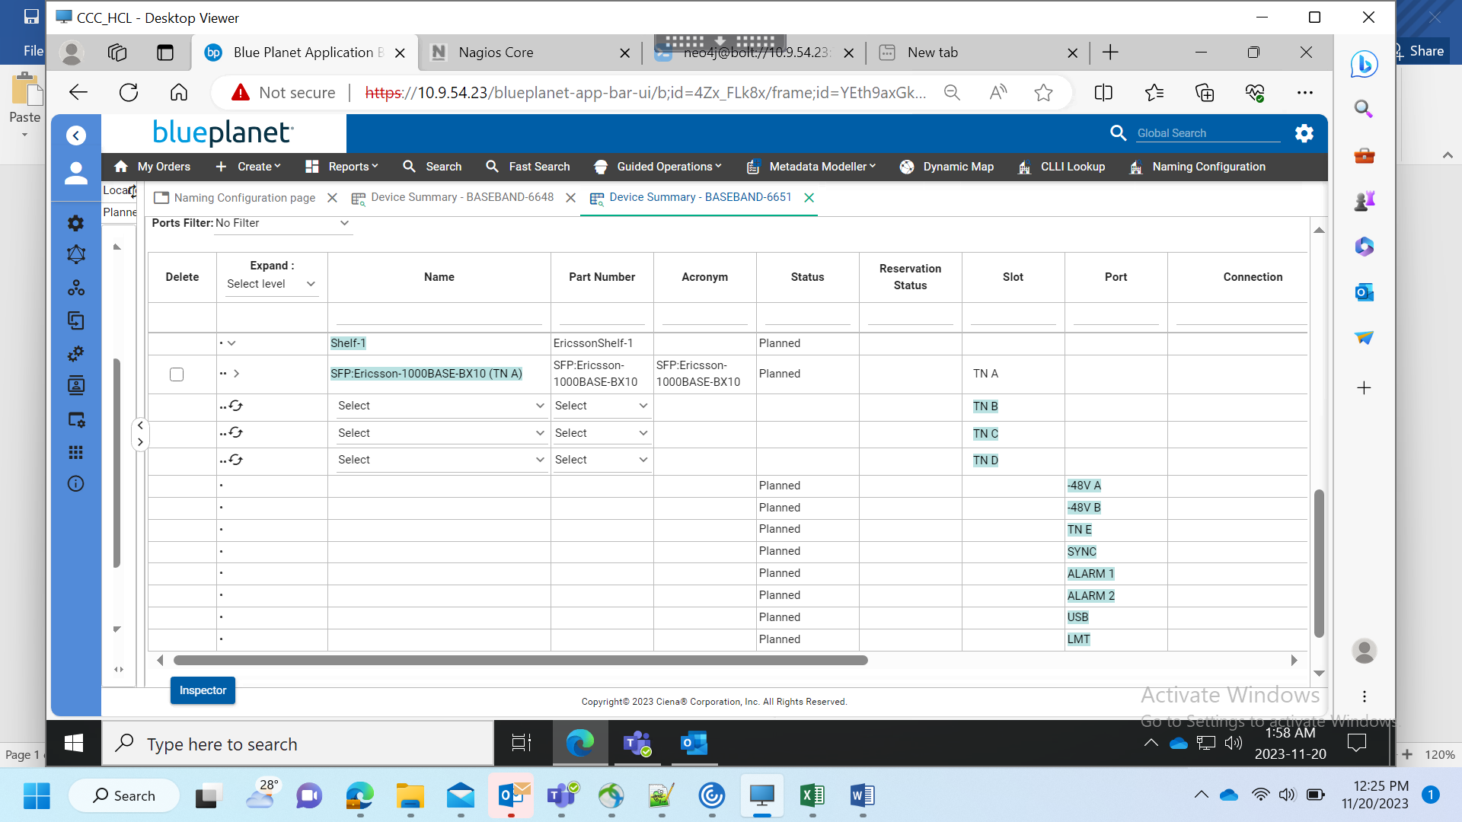

BB 6502:

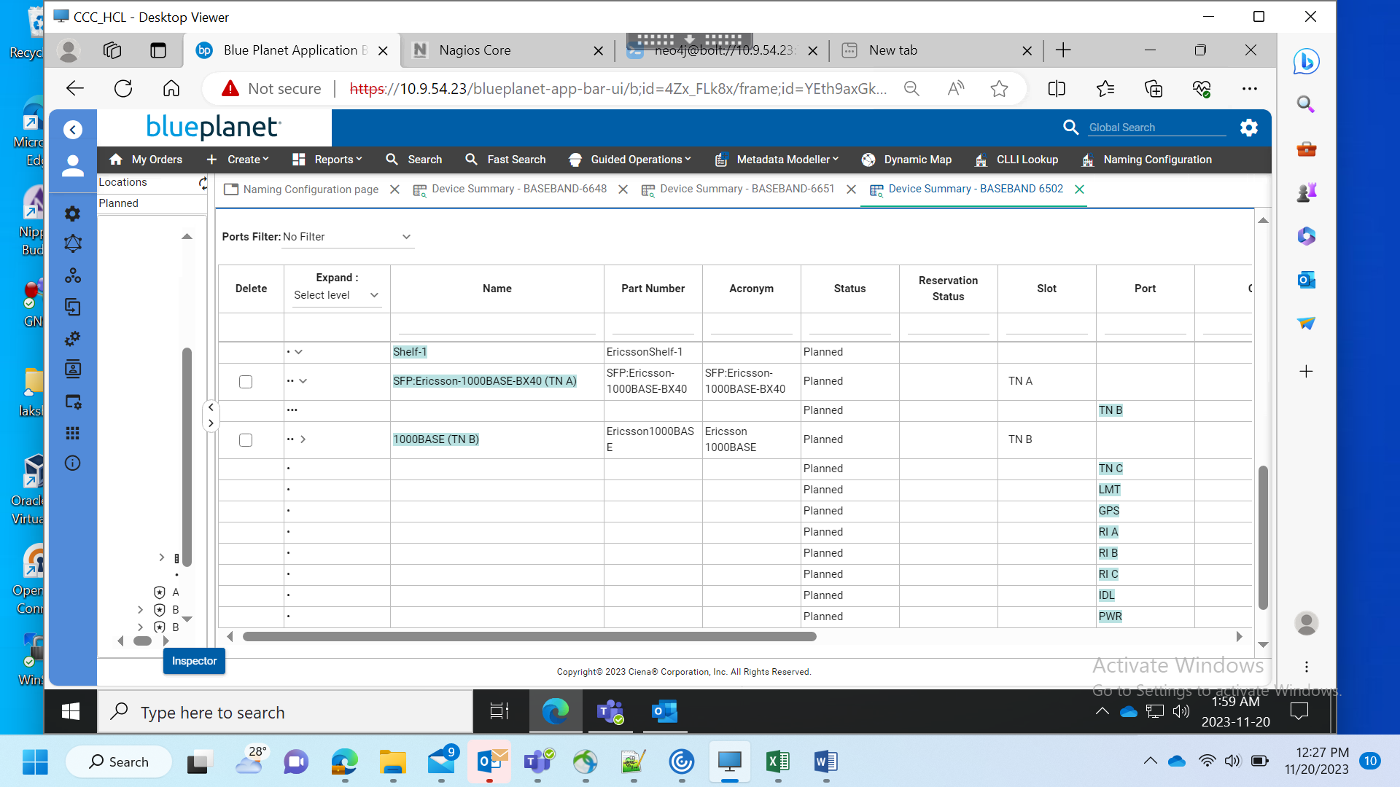

BB 6705:

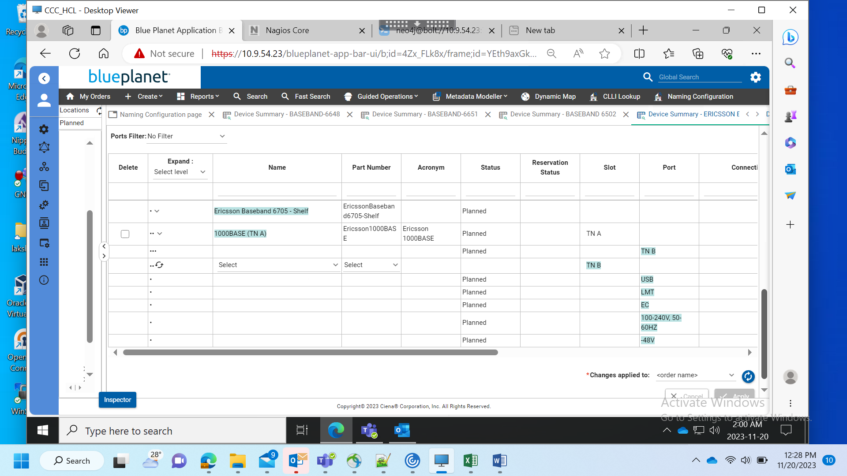

BB 6620:

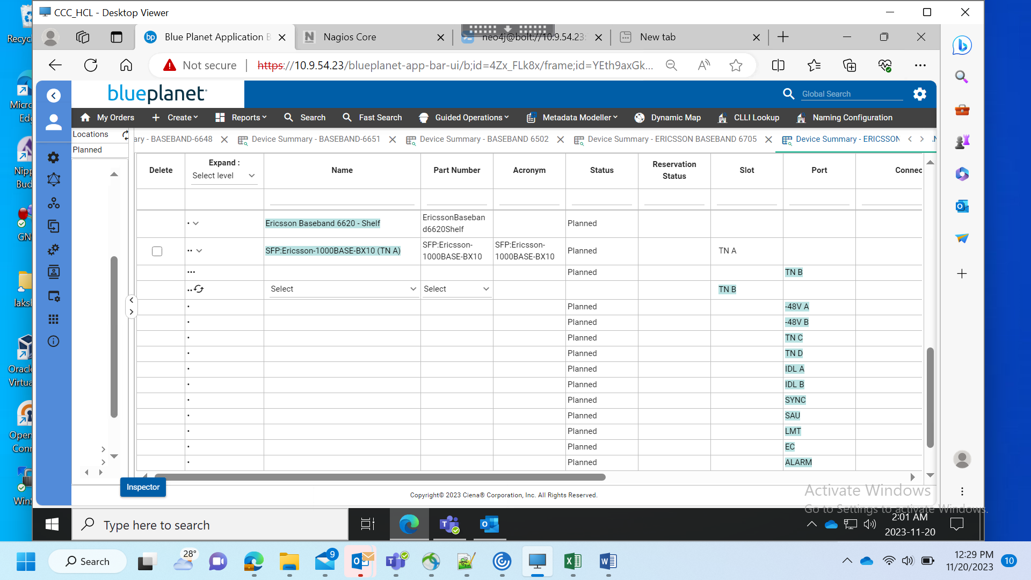

Device Naming Configuration:

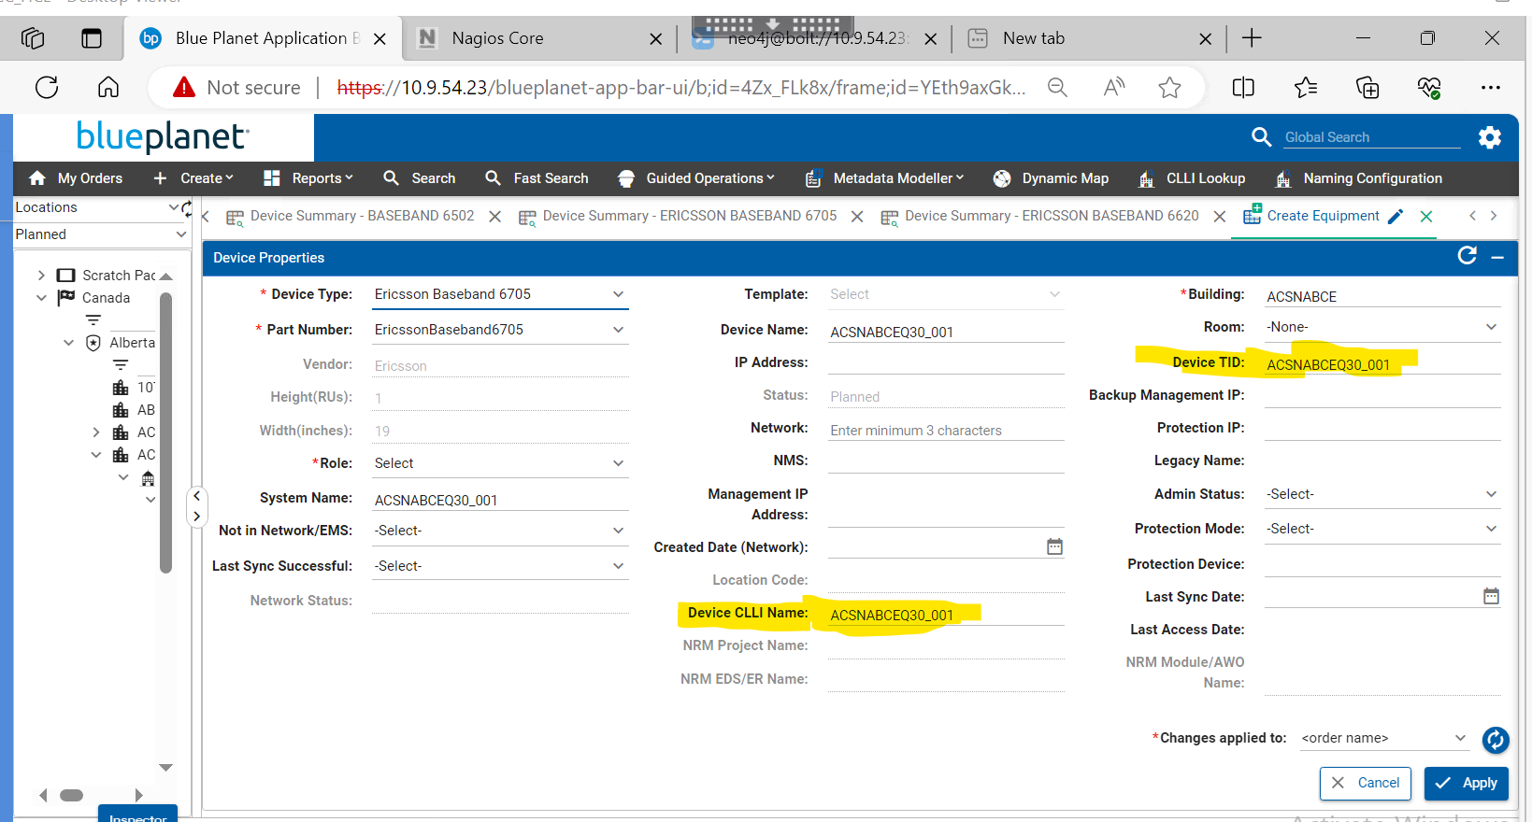

BB 6620:

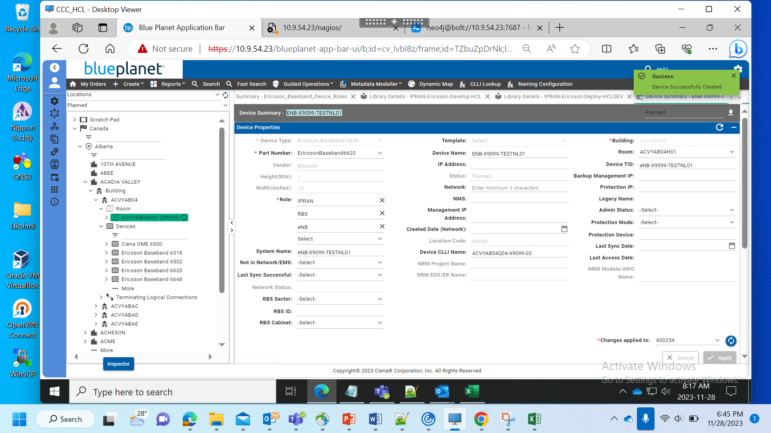

BB 6648:

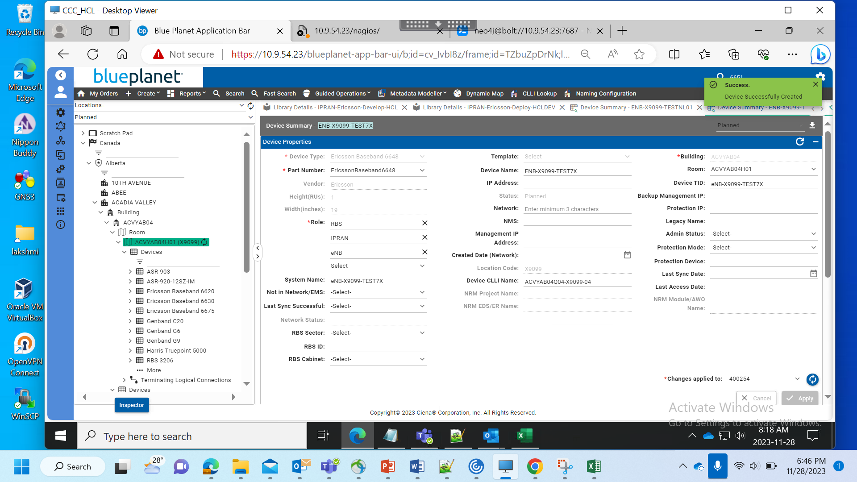

BB 6705:

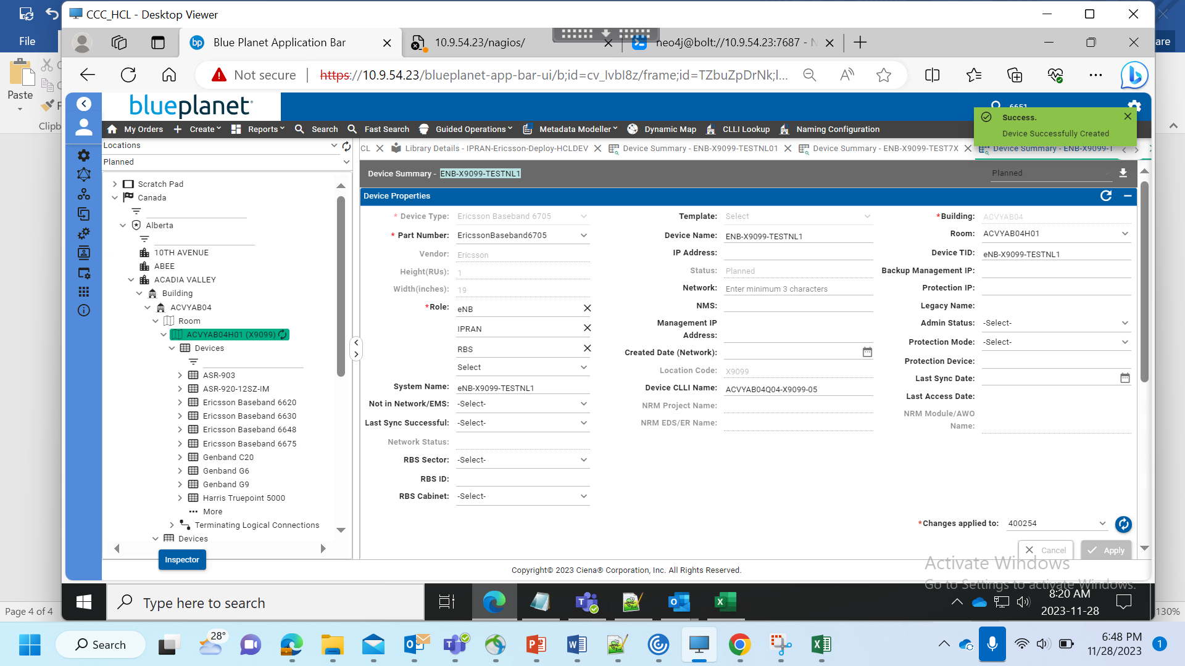

BB 6502:

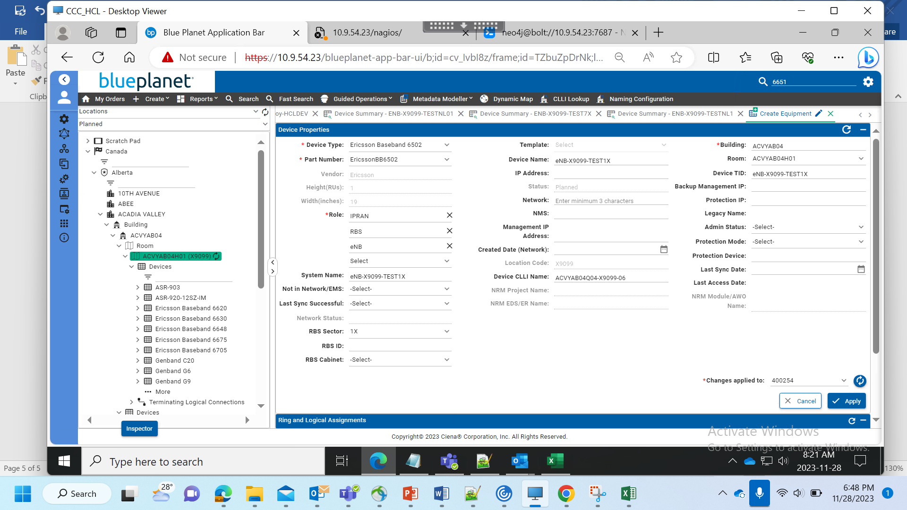

BB 6651:

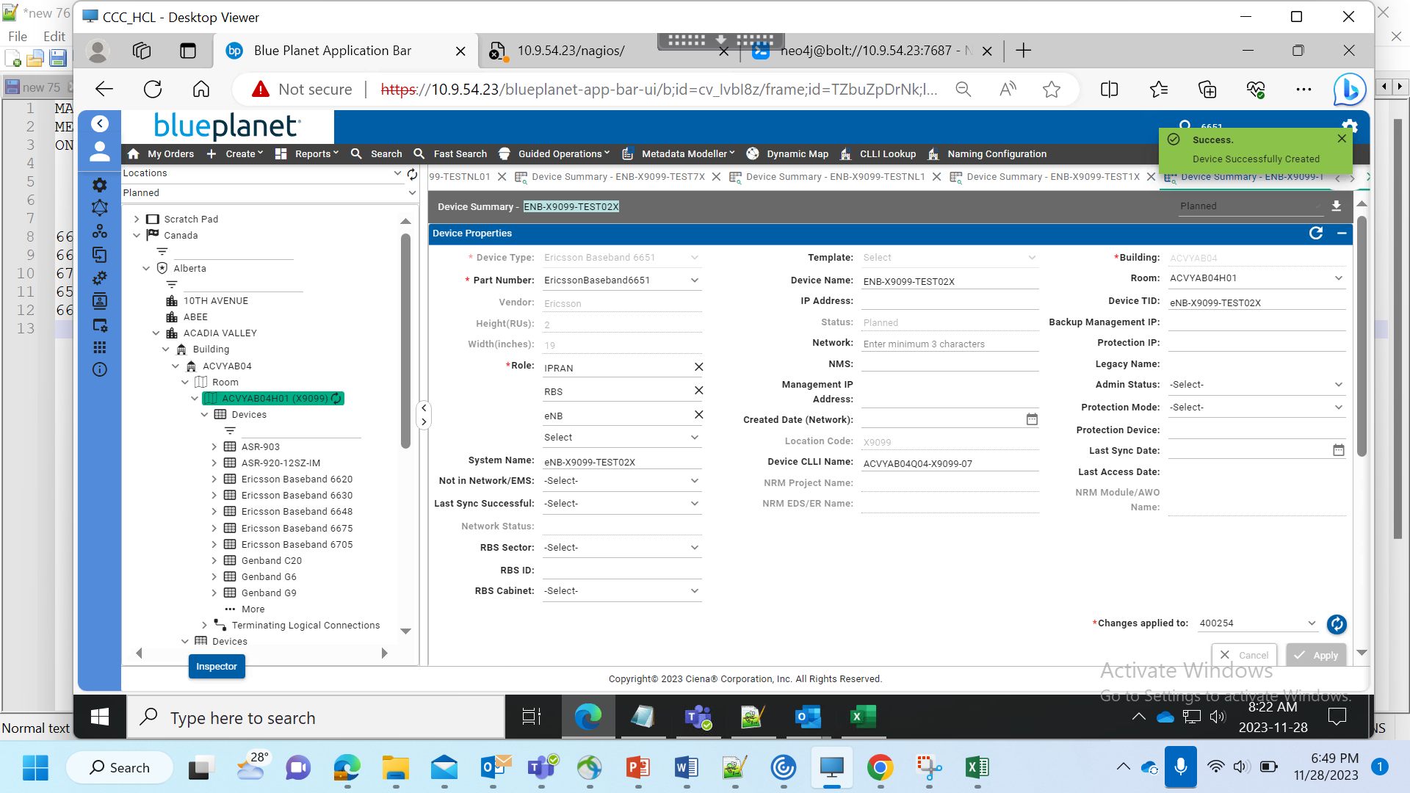

Following changes have to be made with the Waveserver Device:

1. Slot 1-8 are all service
2. The WS 2xWL5E C-BAND  PREMIUM 16XQSFP28/QSFP-DD MODULE is actually a double slot card so it occupies: Slot 1&2, Slot 3&4, Slot 5&6 and Slot 7&8
3. We need 4 additional slots which will actually be the Control Panel, Access Panel and the Power/Fan Slot

So basically the following changes need to happen:

1. Create 4 new slots and label them as following:
2. Control Panel
3. Access Panel
4. Power&Fan
5. Power&Fan

1. Compatibility for these new slots will be mapped as following:
2. Cards currently compatible with Slot 2 will be made compatible with the slot Control Panel
3. Cards currently compatible with Slot 4 will be made compatible with slot Access Panel
4. Cards currently compatible with Slot 6 and Slot 8 will be made compatible with the two Power&Fan Slots
5. Remove the current card compatibility for Slot 2,4,6 and 8
6. The WS 2xWL5E C-BAND  PREMIUM 16XQSFP28/QSFP-DD MODULE is a double slot card which can on go in Slot 1,3,5 and 7 but occupies the following slot pairs:
7. Slot 1&2
8. Slot 3&4
9. Slot5&6
10. Slot 7&8

I have tried to put all of this in a pictorial format as well:

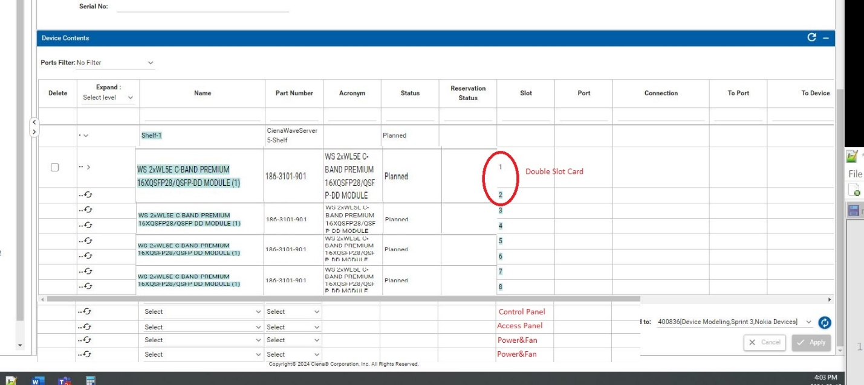

Solution:

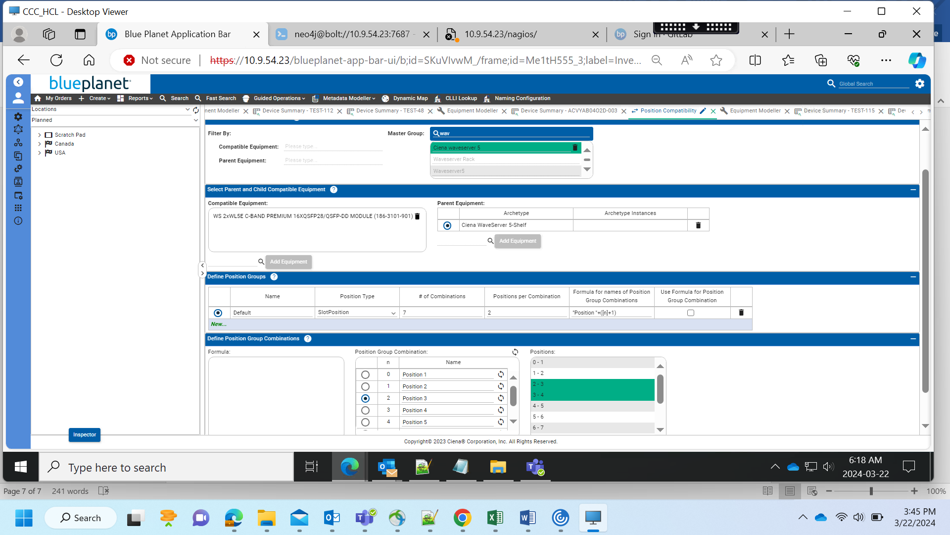

The fix for the slot compatibility – I did the following in the DB after deploying Library 36

//delete

match (ag:AddressGroup)-[:GROUPS]->(agi:AddressGroupInstance) where ag.drniId = 260508169046125235 and agi.name in ['Position 2','Position 4','Position 6'] detach delete agi;

Basically, I am deleting position groups 2, 4 and 6 which made the card compatible with Slot(2,3), Slot(4,5)  and Slot(6,7)

Adding ShelfAID:

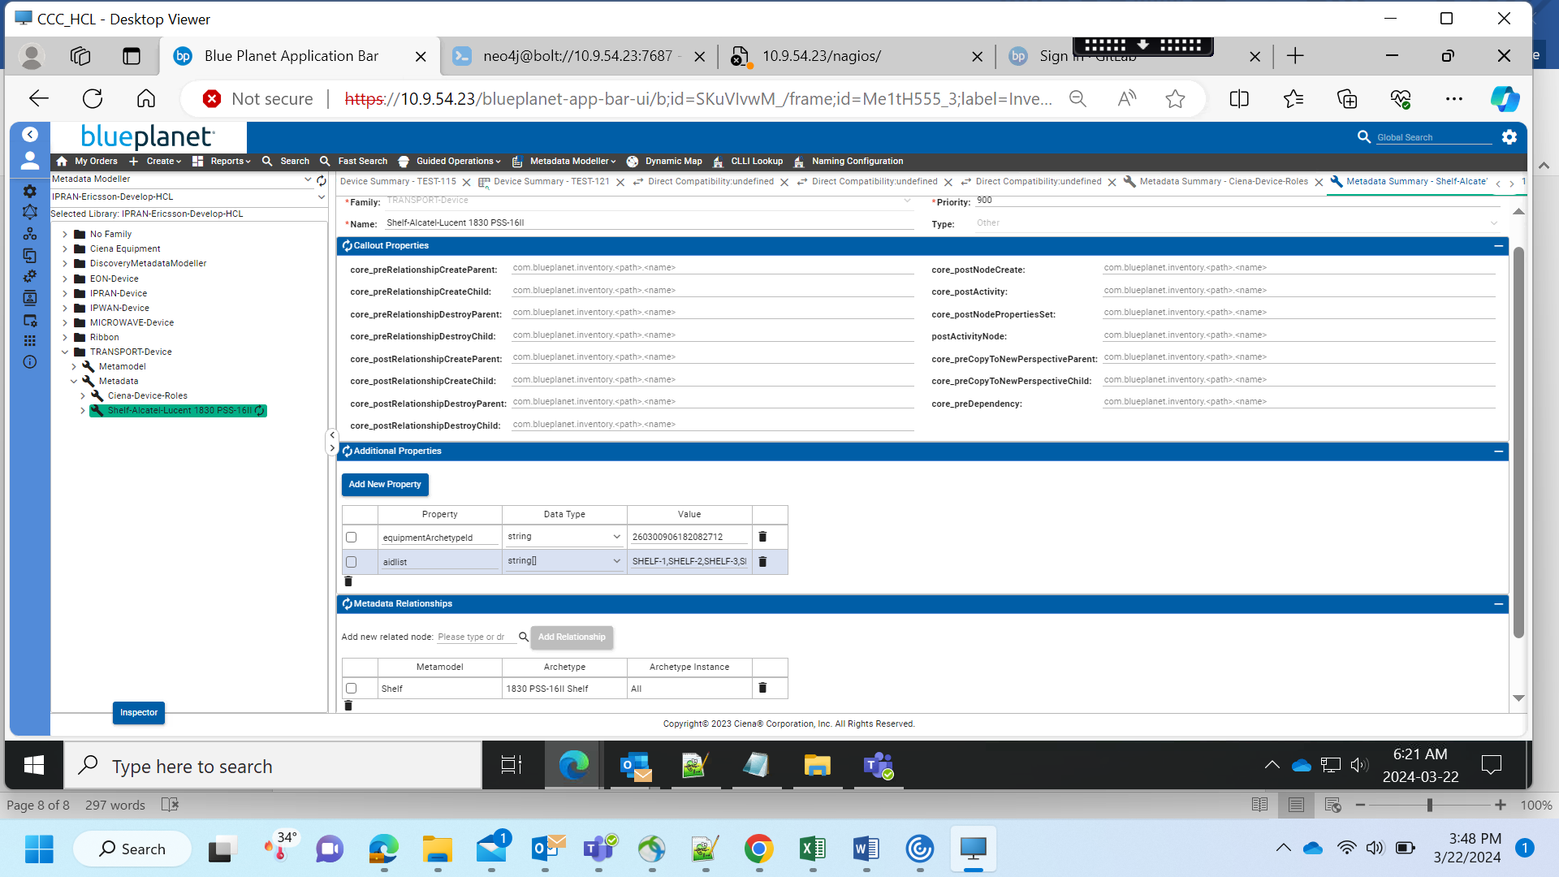

equipementArchetypeId = Shelf DrniId

[3:52 PM] BandaruKumara Lakshm - EXT

CMD42-51,CMD42-East,CMD42-52,CMD42-West,CMD42-53,CMD42-54,CMD42-55,CMD42-56,CMD42-57,CMD42-58,CMD42-59,CMD42-60,CMD42-61,CMD42-62,CMD42-63,CMD42-64,CMD42-65,CMD42-66,CMD42-83,CMD42-84,CMD42-85,CMD42-86,CMD42-87,CMD42-88,CMD42-89,CMD42-90,CMD42-91

[3:52 PM] BandaruKumara Lakshm - EXT

SHELF-1,SHELF-2,SHELF-3,SHELF-4,SHELF-5,SHELF-6,SHELF-7,SHELF-8,SHELF-9,SHELF-10,SHELF-11,SHELF-12,SHELF-13,SHELF-14,SHELF-15,SHELF-16,SHELF-17,SHELF-18,SHELF-19,SHELF-20,SHELF-21,SHELF-22,SHELF-23,SHELF-24

Adding roles:

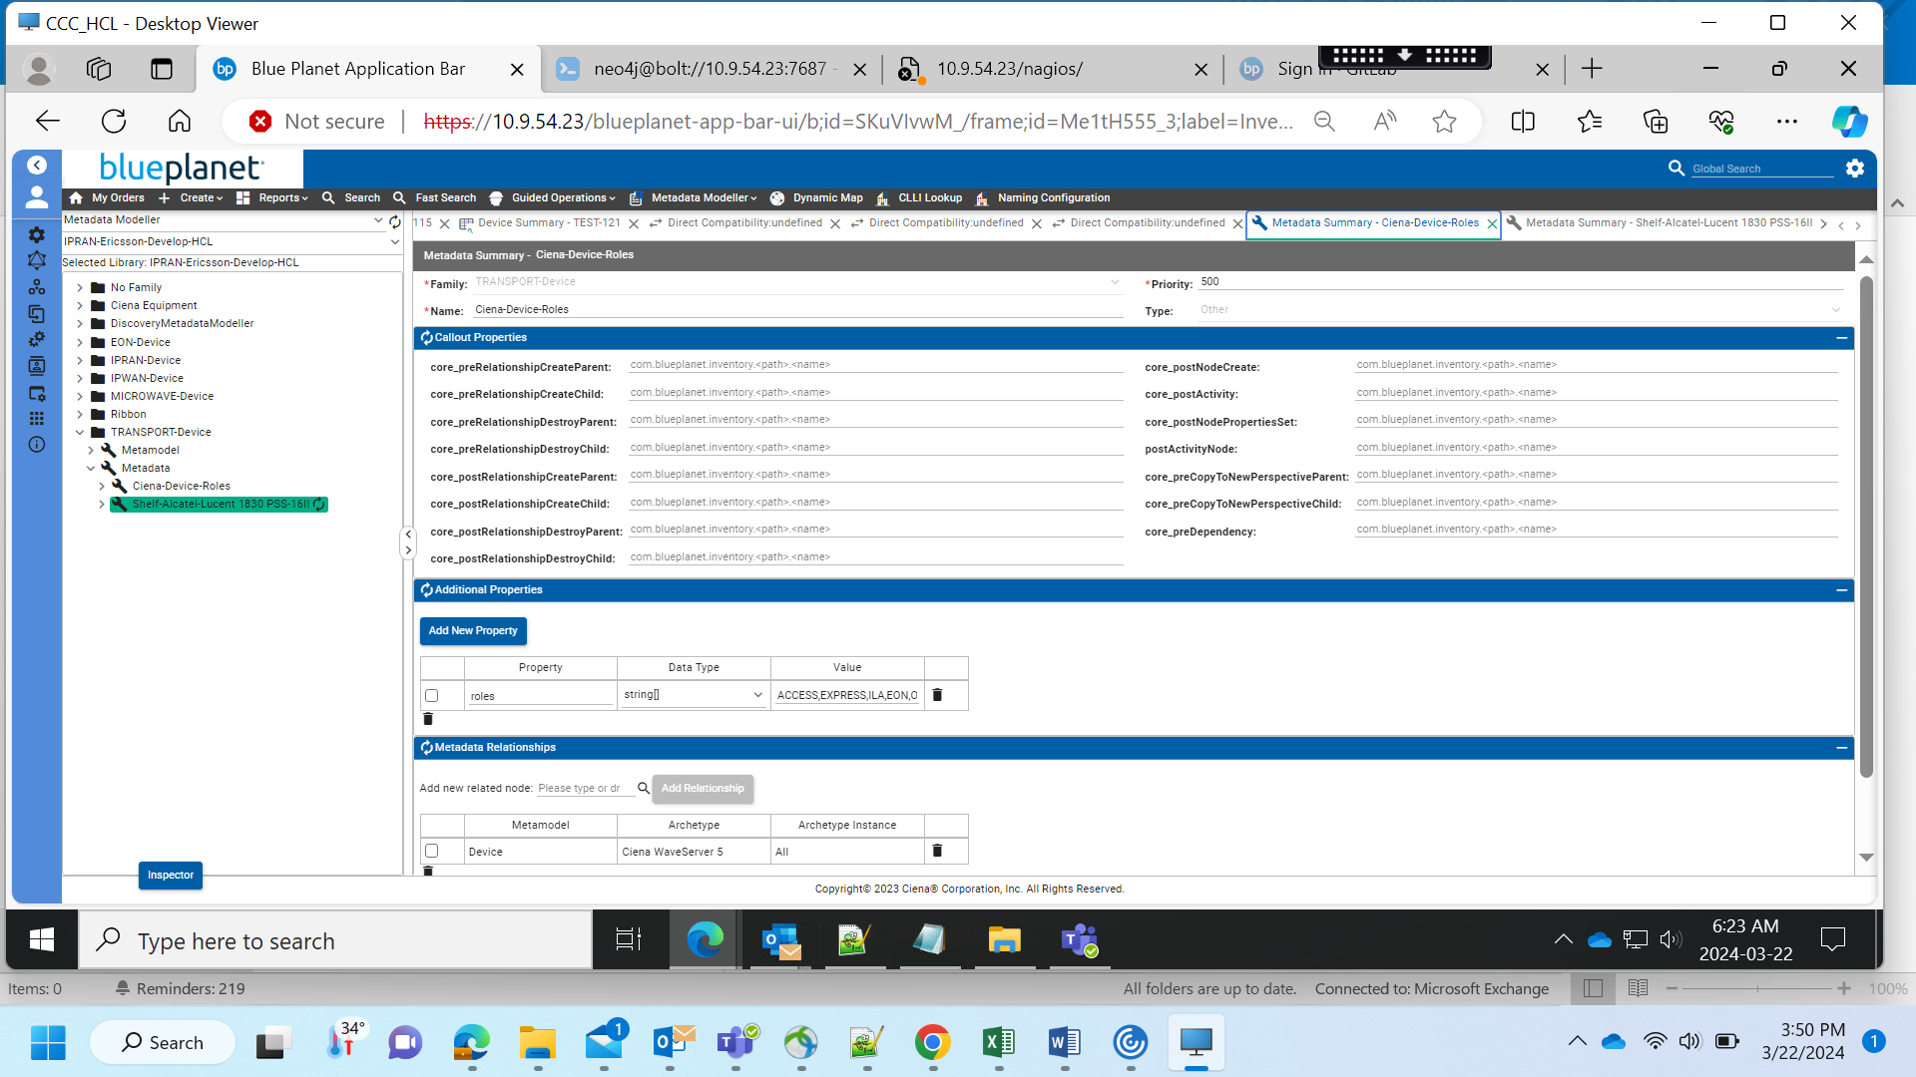

[2/7 4:51 PM] BandaruKumara Lakshm - EXT

Lakshmi Deployment Libraries:  
sprint-1 : IPRAN-Ericsson-Deploy-HCLDEV  
sprint-2 : IPRAN-Cisco-Deploy-HCLDEV-SP2  
sprint-3 : HCl_DEV-1-SP3

Anil Deployment Libraries:  
Sprint-1 : Nov23-SP1-Ericsson-Deply   
Sprint-2 : Nov23-SP2-Cisco-Deploy

Prasanth Deployment Libraries:  
sprint-1: DDeploy-IPRAN-Ericsson-Nov23  
sprint-2: IPRAN_HCL_DEV3  
sprint-3: HCL_DEV-3-SP3

Supraja Deployment Libraries:  
sprint-2: IPRAN-HCL-Sprint2-DEV4  
sprint-3: HCL_DEV4_SP3

Alakrutha Deployment Libraries:  
sprint-2: IPRAN-HCLDEV-Sprint2-Deploy-V2  
sprint-3: HCL_DEV-2-SP3

Rama Deployment libraries:  
sprint-2: TRANSPORT-Deployment-SR-HCl2  
sprint-3: HCL-DEV5-SR-SP3

[2/7 5:04 PM] BandaruKumara Lakshm - EXT

Lakshmi Deployment Libraries:  
sprint-1 : IPRAN-Ericsson-Deploy-HCLDEV  
sprint-2 : IPRAN-Cisco-Deploy-HCLDEV-SP2  
sprint-3 : HCl_DEV-1-SP3  
  
Anil Deployment Libraries:  
Sprint-1 : Nov23-SP1-Ericsson-Deploy   
Sprint-2 : Nov23-SP2-Cisco-Deploy  
Nov23-SP1-Ericsson-Deploy-v1.1  
  
Prasanth Deployment Libraries:  
sprint-1: DDeploy-IPRAN-Ericsson-Nov23  
sprint-2: IPRAN_HCL_DEV3  
sprint-3: HCL_DEV-3-SP3  
HCL_DEV-3-SP3_V1  
  
Supraja Deployment Libraries:  
sprint-2: IPRAN-HCL-Sprint2-DEV4  
sprint-3: HCL_DEV4_SP3  
HCL_DEV4_SP3_V1  
  
Alakrutha Deployment Libraries:  
sprint-2: IPRAN-HCLDEV-Sprint2-Deploy-V2  
sprint-3: HCL_DEV-2-SP3  
  
Rama Deployment libraries:  
sprint-2: TRANSPORT-Deployment-SR-HCl2  
sprint-3: HCL-DEV5-SR-SP3

I have restored the database to a copy of the SIT/Prod data from early January. **It does not have the HCL metadata yet**.

I have also deployed Build 1169 in the environment

In case you want to refresh the DB again to test multiple times – please follow the instructions below to restore the DB

Login to 10.9.54.24  (bpadmin/bpadminpw)

* sudo solman
* enter_container neo4j + TAB     

Inside the container

* cd /bp2/tmp

Stop neo4j

* supervisorctl stop neo4j

Restore backup

*    NOTE – the name of the dump file here is **neo4j_SITBKP_01082024.dump** – not what is shown in the screenshot

Start neo4j

* supervisorctl start neo4j

exit from the neo4j container

* exit

Wait 2 mins

Restart the web server from “sudo solman”

* 

Wait about 3-5 mins for the solution to restart and then login to the BPI UI

In the .23 (DEV) neo4j database, I checked the IDs and they are for Library and Library Plan objects

match (ai:Library) where ai.BPIUId = 'bpi.rogers.sp1.ericsson.deploy.v1.1.261246898499518588' return ai;                    → This returns a Library

match (ai:Plan) where ai.BPIUId = 'bpi.rogers.sp1.ericsson.deploy.v1.1.261246898499518589' return ai;                  → The above library “HAS” this Plan.

Setting up 10.9.54.24

Create the following folders

/home/bpadmin/baseRestWarForMM/build1169

/home/bpadmin/baseRestWarForMM/current

From 10.9.54.24, use SFTP to 10.9.54.7 to get the build 1169 war file to the /home/bpadmin/baseRestWarForMM/build1169 folder

Here are the instructions for deploying build 1169 for import/deploy of libraries

In 10.9.54.24

* cd /etc/bp2/custartifacts/custpackage/web/webapps

Copy the current war file to the “current” folder

* sudo cp blueplanet-inventory-rogers-rest.war /home/bpadmin/ baseRestWarForMM/current/.

Copy build 1169 to webapps

* sudo cp /home/bpadmin/baseRestWarForMM/build1169/blueplanet-inventory-rogers-rest.war .

Start Custartifacts

* sudo solman
* (Cmd) solution_app_restart artifactory.ciena.com.blueplanet.bpinvcustartifacts:21.10.8-1662729950 custartifacts

Wait about 5 mins before connecting to UI

Do Import/Deploy of all the libraries and do sanity test

IF you want to restore the original build – then copy from “current” folder to “webapps” folder and restart custartifacts (FOR NOW YOU CAN LEAVE Build 1169 in this environment).

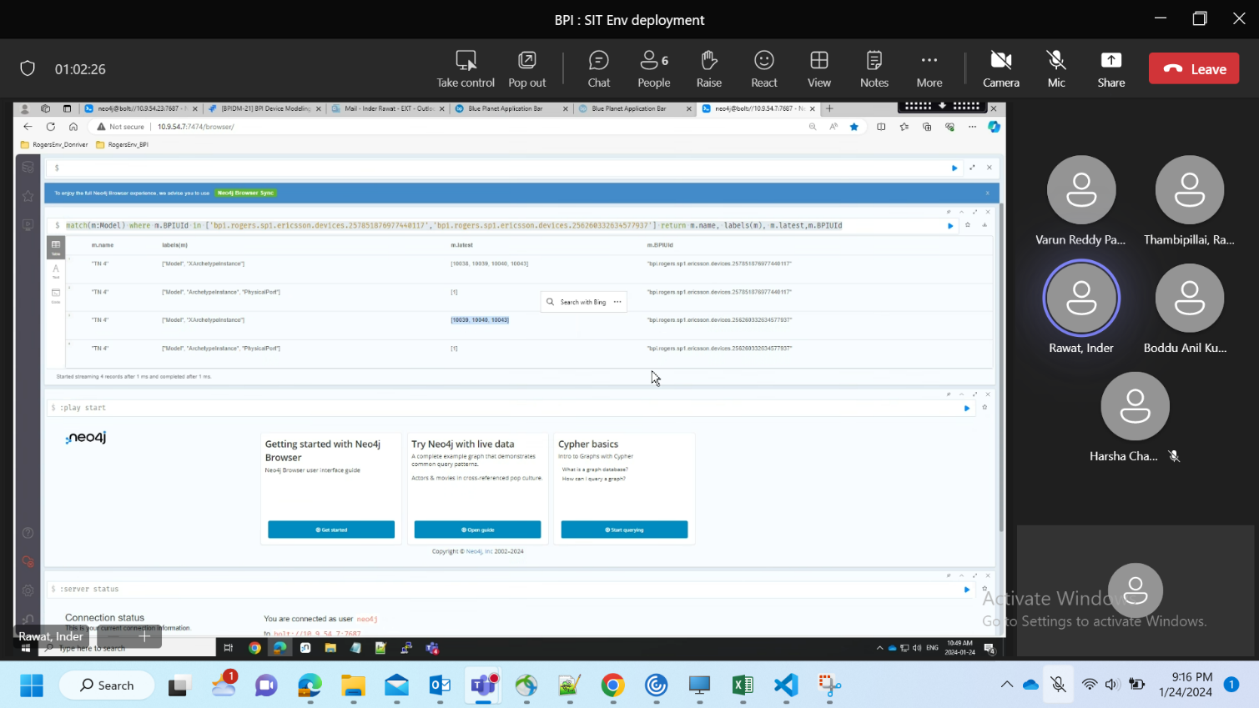

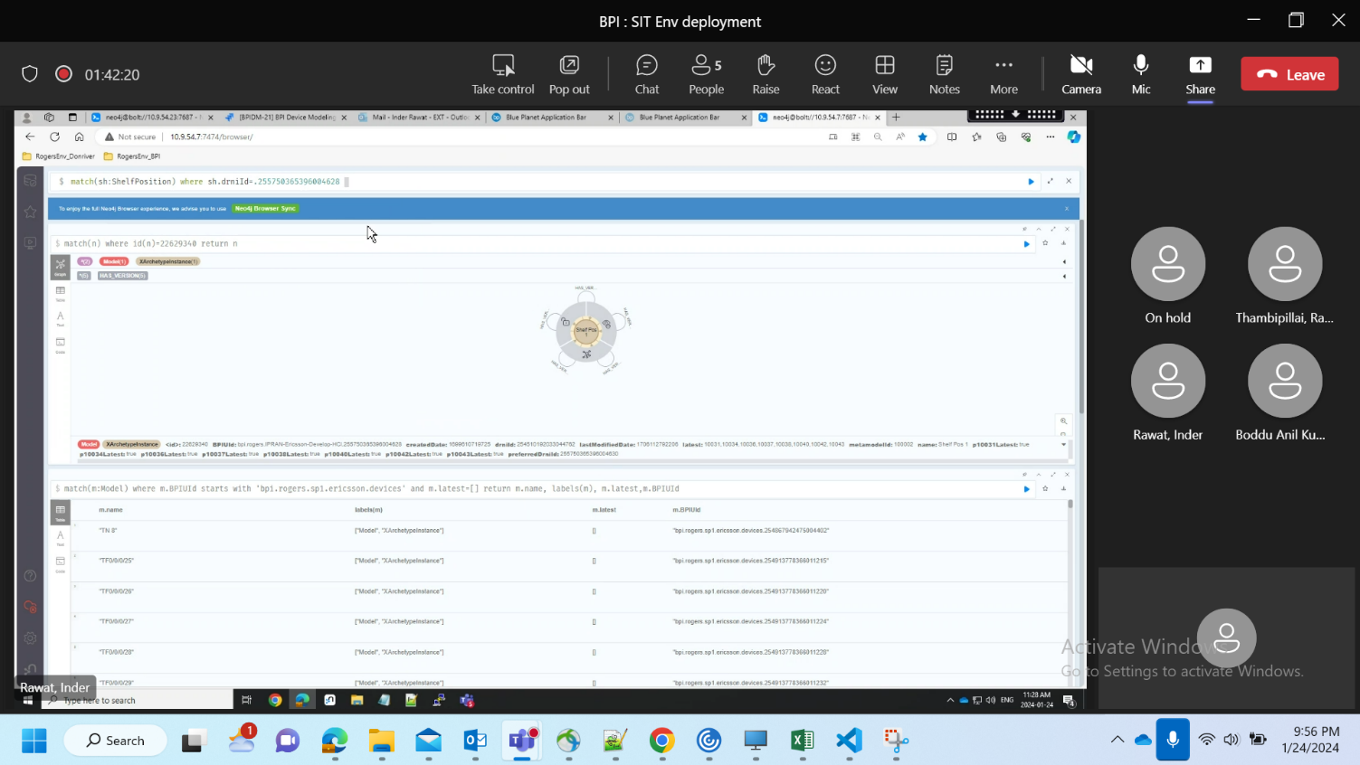

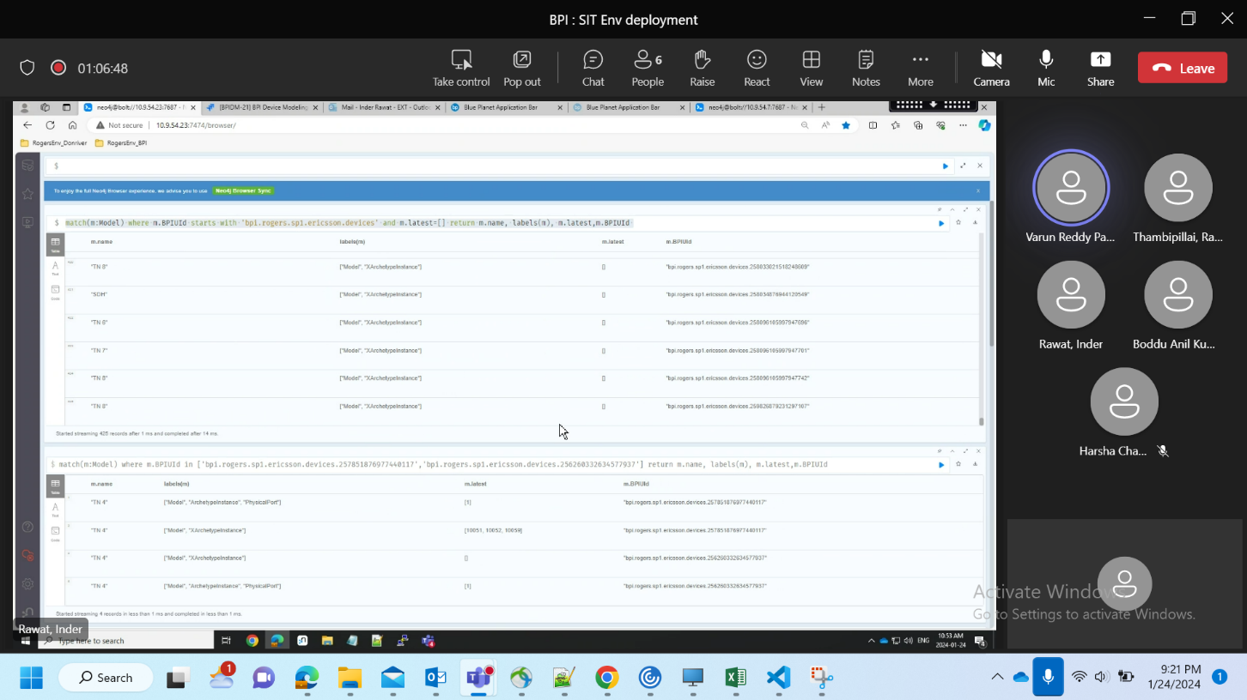

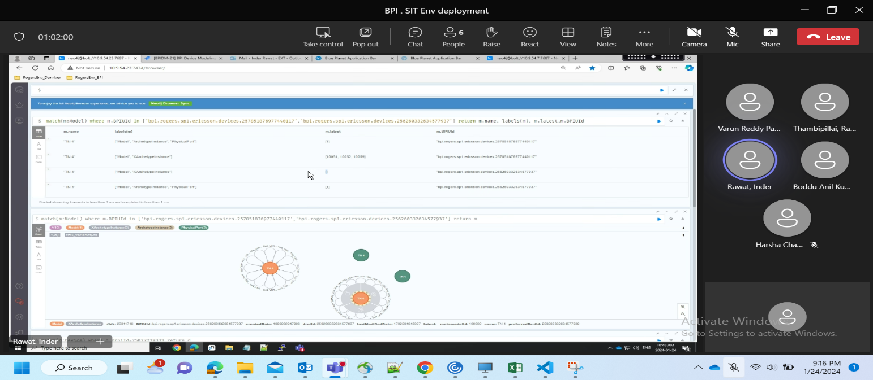

Github Process:

